**STEP BY STEP MANUAL FOR SETTING UP THE GIT HUB REPOSITORY FOR VEHICLE SCHEDULING POC**

**INSTALLING NODE JS**

1. Download Node JS executable for windows from node.js website.

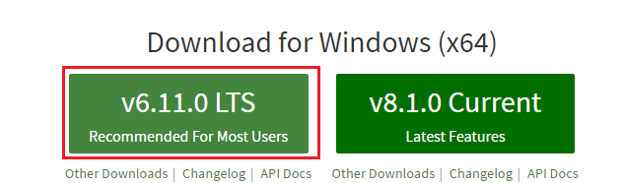

1. Install Node JS in your PC. Installation will require administrator user id and password.

**FORKING A GITHUB REPOSITORY**

1. Open given GitHub repository.

<https://github.com/WillSnowdon/angular-starter>

1. Complete ‘Sign up’ in GITHUB.

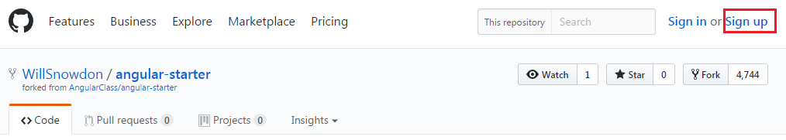

1. Again open the given GitHub repository and click on Fork.

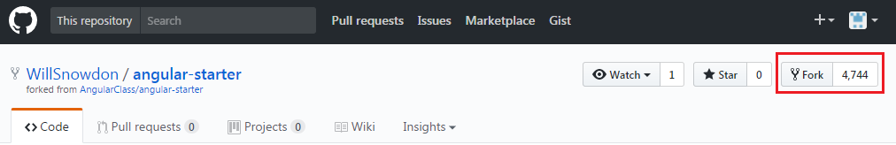

1. This creates your own copy of the intended repository.

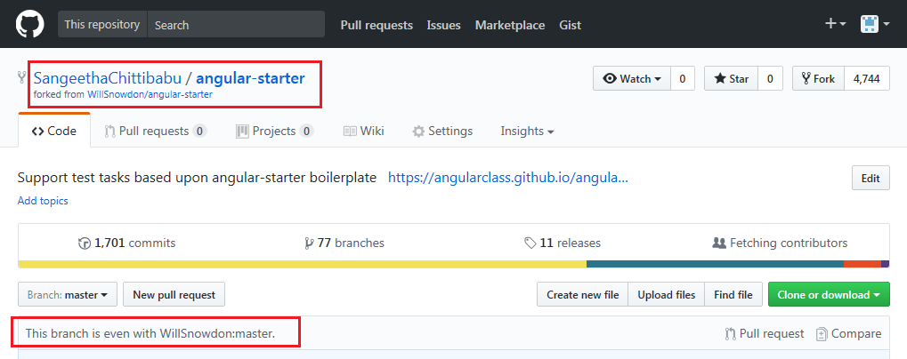

**SETTING UP A WORKING FOLDER**

1. You can either ‘Clone or Download’ this repository to your local machine or Open any IDE and follow the below example given using Eclipse. Please note that IDE is not mandatory for setup.
2. Open a workspace and import the GITHUB repository using steps below.

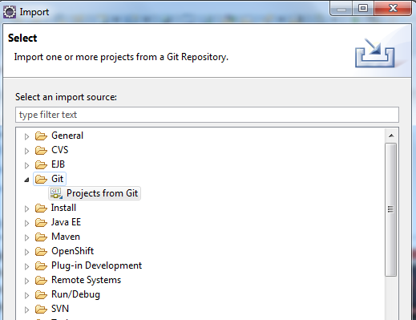

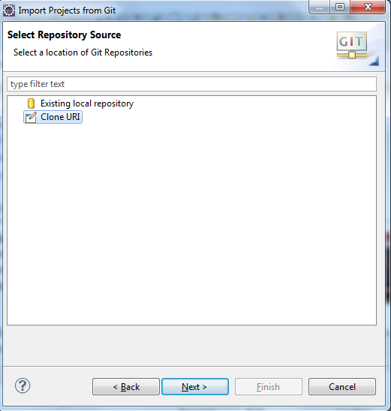

1. Provide the URL of the forked repository and click next.

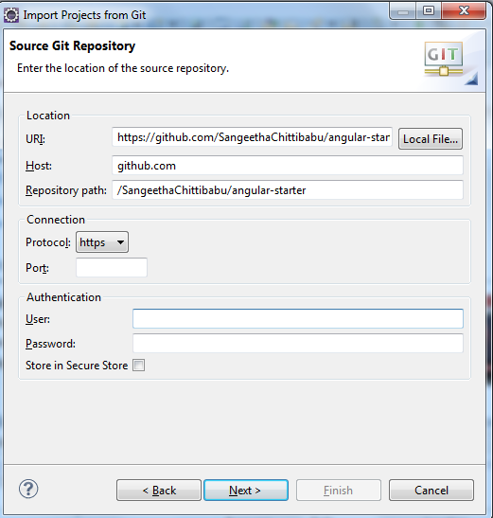

1. Choose a destination directory.

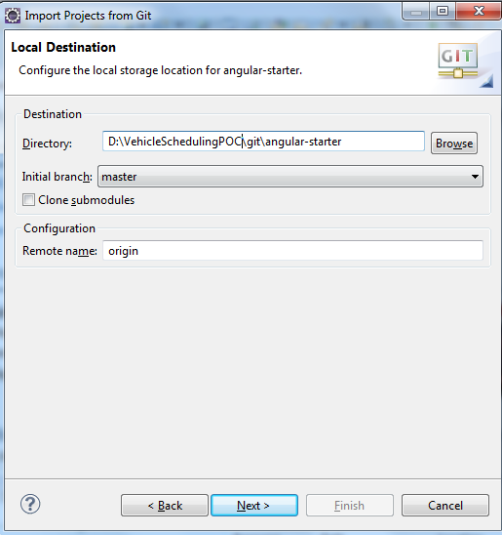

1. Import as general project and click on finish.

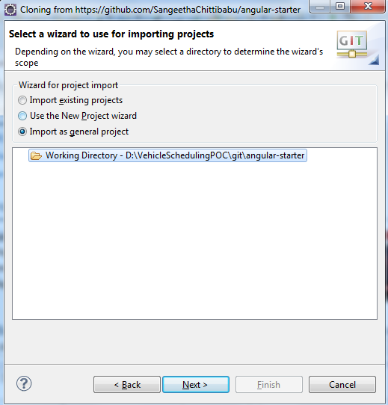

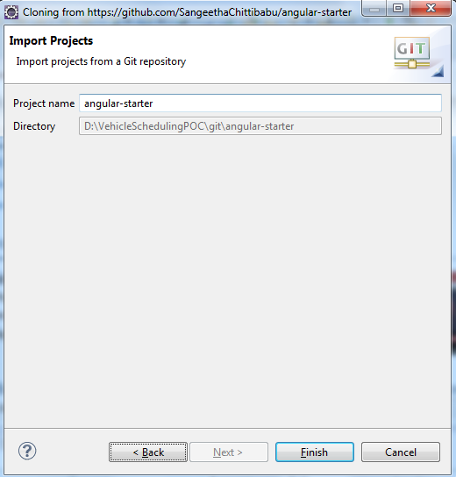

**INSTALLING DEPENDENCIES**

1. After import is complete, the workspace folder will resemble as below.

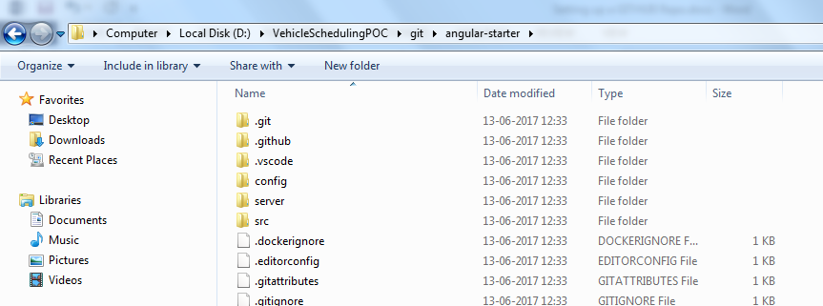

1. This project requires certain package dependencies as declared in package.json file. To download those, we need to execute the below command in specified directory path. After the download gets completed, you will see a ‘node_modules’ folder in workspace folder.

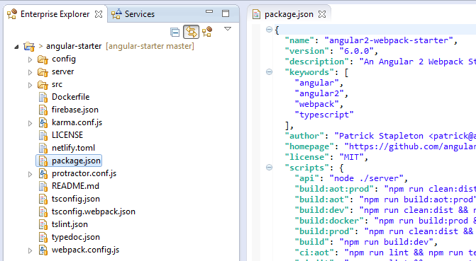

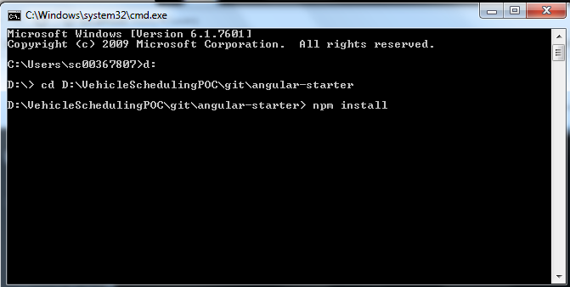

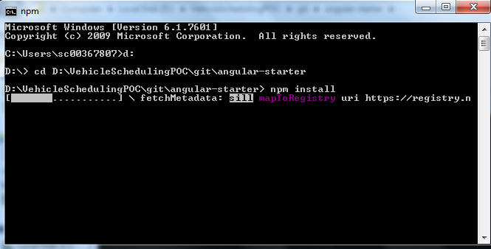

Please note that the above step requires a stable network and justifiable speed.

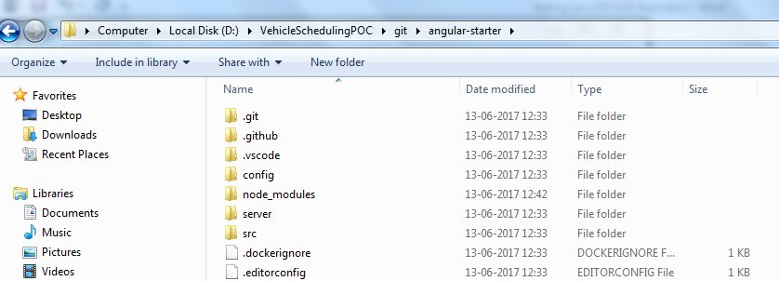

STARTING SERVER AND API

1. Use the below commands to start the npm server and api.

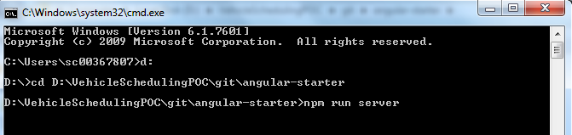

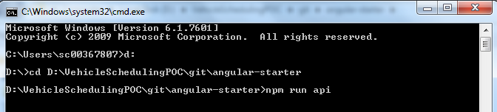

1. Now we can access the application from the below URL and proceed with the tasks.

<http://localhost:3000/>

**COMMITING A CHANGE TO FORK**

1. Once you have made a change and want to commit files, do so using Team🡪Commit🡪Commit and Push option

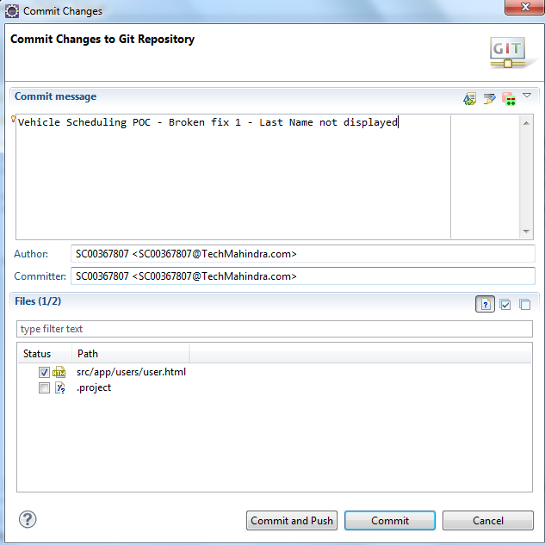

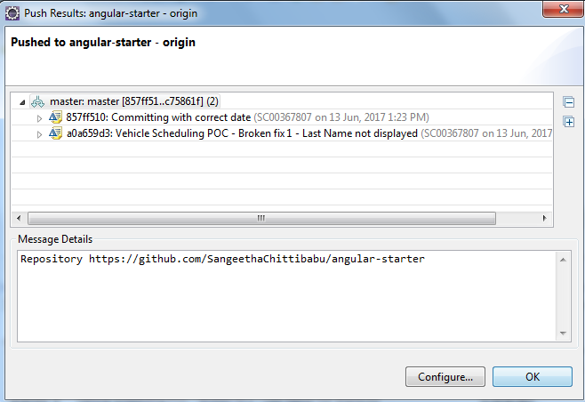

Use GITHUB user id and password.

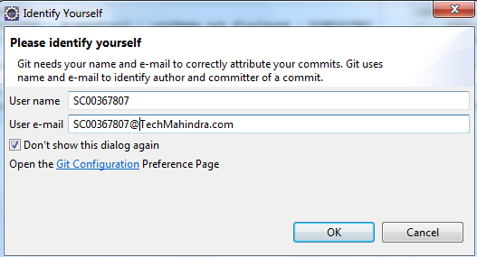

Once changes are pushed, the same will be visible in GITHUB forked repository online.

